PJM530

**Herguan University**

**Professor:** Wiselin Mathuram

Mid Term II – Take home Project + Class Demo

**12/05/2015 Summer 2015**

**Name:Ravi Kumar Mekala132032**

**ID:**

**Score 100**

**Do the below project document your results with screenshots and also list the assumptions if the requirements are not complete. Your working software will be checking in class.**

**Subscribe to rally (Community edition)**

**https://www.rallydev.com/get-started**

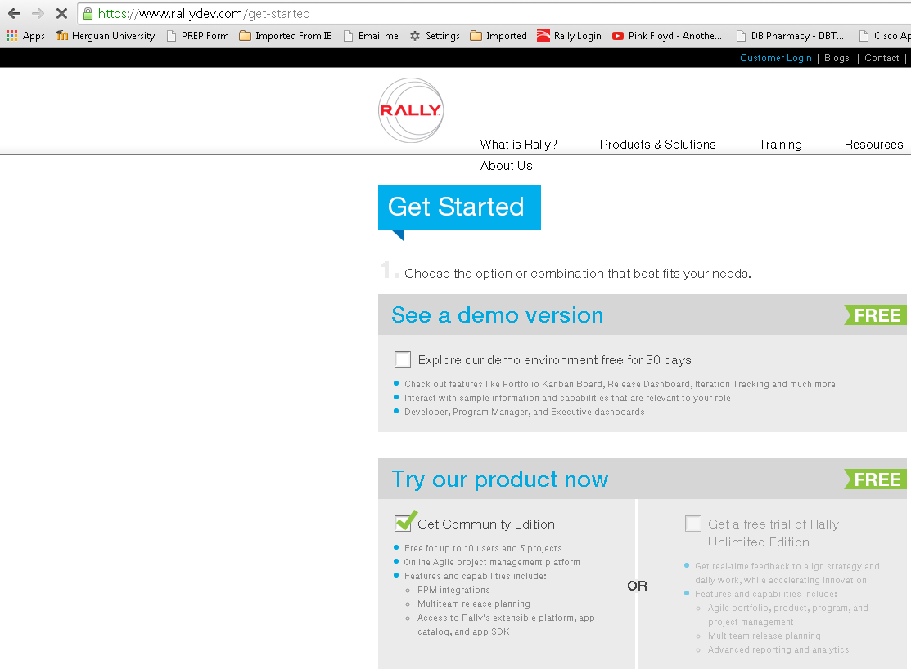

**Team size 4 (2 Developers, 1 QA, 1 scrum master/Dev) + (1 product owner)**

**Team velocity 6 story points**

1. Create a project under a workspace
   1. Tax Enhancements
2. Create two releases
   1. Release 1 duration

5/1 to 5/30

* 1. Release 2 duration

6/1 to 6/30

1. Under Release 1 create two iterations
   1. Sprint 1 – 5/1 to 5/15
   2. Sprint 2- 5/16 to 5/30
2. Under Release 2 create one iteration
   1. Sprint 1- 6/1 to 6/19
   2. Hardening Sprint 2 6/20 to 6/30
3. Add stories to backlog
4. Complete estimation board

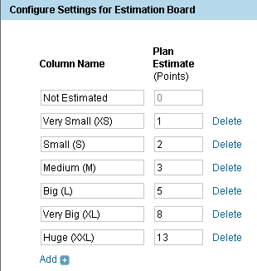

1. Assign stories to sprints and releases
2. Assign tasks to stories (each story should have an analysis, dev and test task) – Use the task estimation guideline below

Estimate Team Capacity

Capacity = # Teammates (Productive Hrs x Sprint Days)

Example – Team size is 4, Productive Hrs are 5, Sprint

length is 30 days.

Capacity = 4 (5 x30) = 600 hours

NOTE: Account for vacation time during the Sprint!

**Consider the following stories for planning**

(First parameter in story represents priority of requirements, second represents effort)

**Story1 (H, Very Small)**

**As a**EMEA tax business User **I would like**For all invoices (EDI/XML) issues by Cisco Systems Italy (entity code 671, hereinafter referred to as CE Italy), whether under the NL or IT VAT Registration number, shipped to customers that have a Ship To country of Italy, the below wording (red) must appear on the invoice.  It can be placed anywhere, in the same section as the WEEE comment if necessary. **‘Contributo Ambientale CONAI Assolto’ (‘CONAI Environmental Contribution Paid’) So that** compliance regulations are met.

**Story2 (H, Medium)**

**As a**EMEA tax business user **I would Like**All transactions using the I-SVC or CM-SVC (unless the CM references back to a previous invoice as per above) **transaction** type should be taxed as Services using the Bill To location to determine the correct tax code, as opposed to the Ship To Location. **So that** the correct GB VAT Registration are used for the Remit To.

**Story3 (M, Medium)**

**As a** EMEA tax business user **I would like** to enhance The ‘Cisco Tax VAT Number Records Created By The System’**So that** collections can better monitor and correct VAT Numbers that were created   in order to minimize the number of transactions going on hold due to missing customer VAT numbers

**Story4 (M, Medium)**

**As a** customs business user **I would like** the Remittance invoice to roll up duty info for Minor lines and show only at major line level **So that** we do not expose the minor line duty to customers

**Story5 (High, small)**

**As a** IC biz user **I want**   VT to account transactions as shipments with amount  lesser than 0$ **so that** it can be considered as returns

**Story 6 (L, very small)**

**As a** product owner of UKH Sales Tax Register  **I would** like changes made to the report **so that** the R12 report includes Reclass Transactions.

1. Mark a few tasks as complete
2. Go to the dashboard for you and add an app to see your tasks in the dashboard
3. Go to the tracking view as below and get the below view

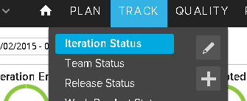

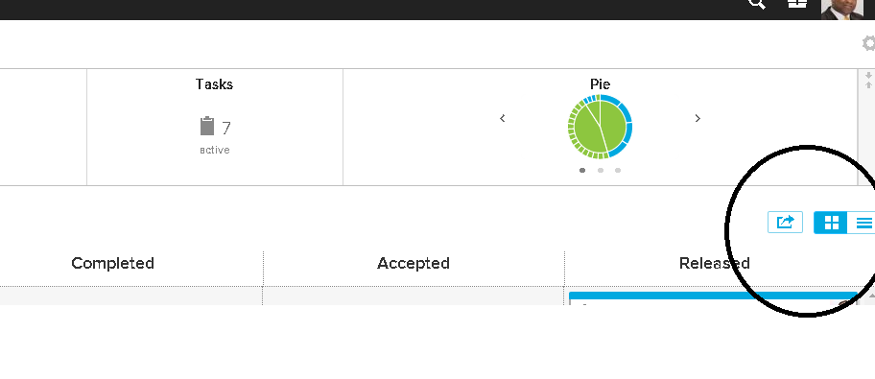

1. Add test cases under a story. (Choose any story to demonstrate)
2. Run a test case and pass one , fail one and add a defect (Chose any story)